## Requirement _UC01 - Add Requirement Use Case [ UseCase ID – UseCase Full Name (heading 2)]

### Class Diagram (heading 3)

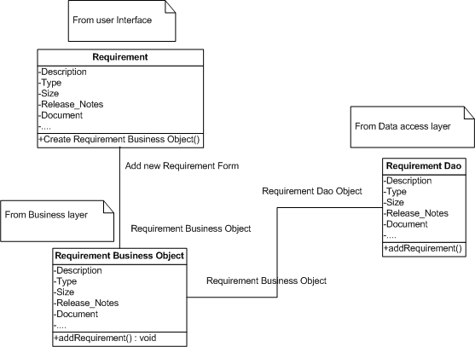

### Sequence flow (heading 3)

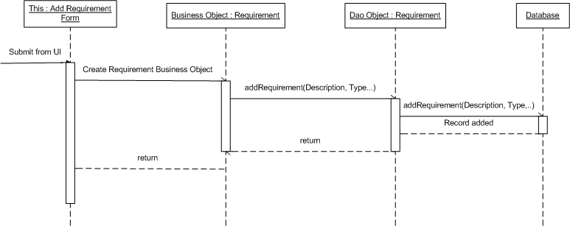

## Requirement _UC02 - Update Requirement Use Case

### Class Diagram

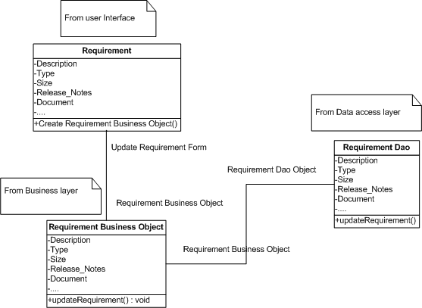

### Sequence flow

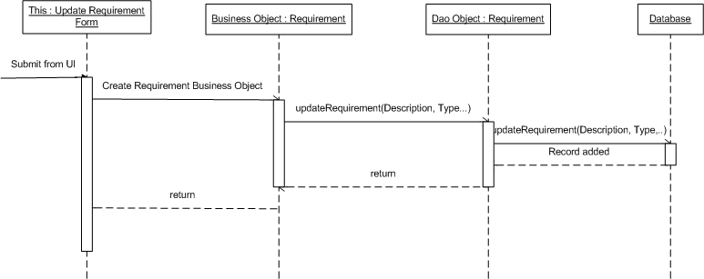

## Requirement _UC03 - Delete Requirement Use Case

### Class Diagram

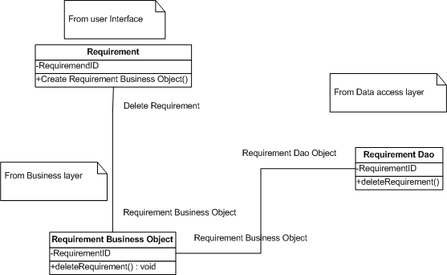

### Sequence flow

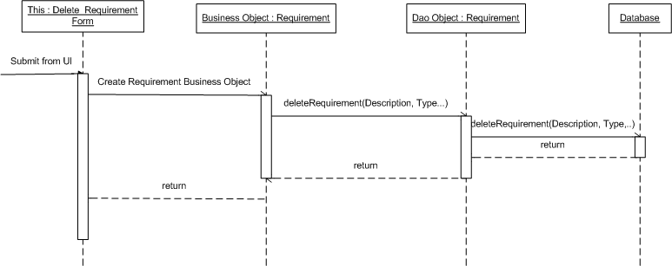

## Requirement _UC04 - Sort Requirements Use Case

### Class Diagram

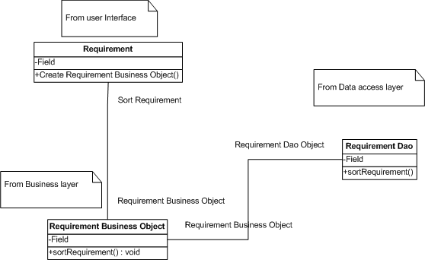

### Sequence flow

